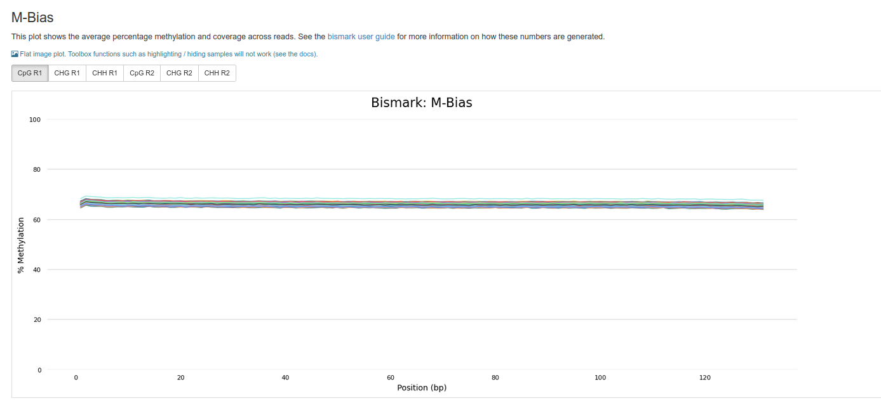

**Figure S1**. Bismark M-bias plot produced by multiQC. This plot represents the coverage and average methylation across reads. The x-axis represents position on read and the y-axis represents methylation percentage at CpG sites.

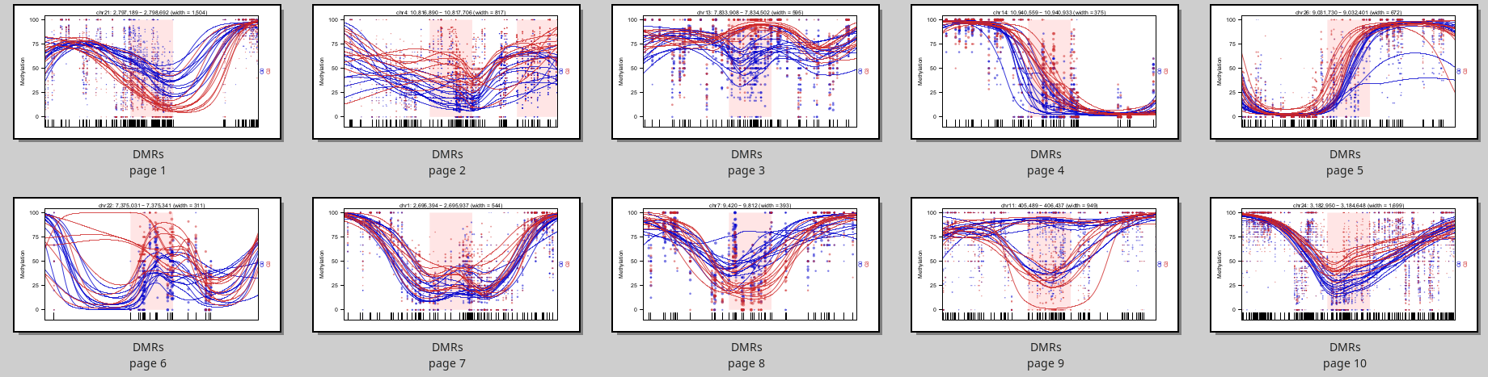

**Figure S2**. Plot of the top10 hypermethylated DMRs. The x-axis is the genomic position and the y-axis is the methylation percentage. Color represents the generation group, blue is G0 and red is G3, each dot represents CpG methylation value, the size of the dots represents the coverage, each line is a smoothed methylation value of each individual, and the highlighted pink area is the region of differential methylation.

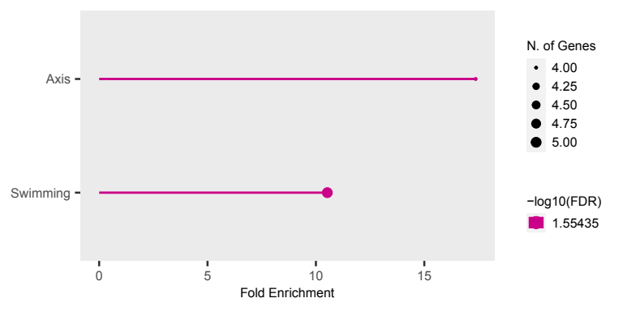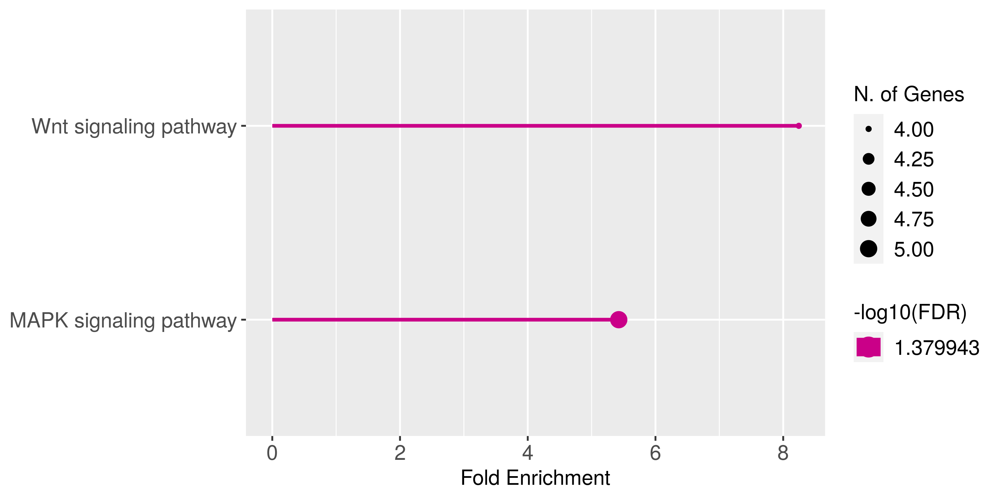

**Figure S3**. Gene Ontology of 201 G0G3 DMRs. The right plot shows the pathway and the left plot shows the phenotype enrichment. **MAPK signaling pathway:** Mitogen-activated protein kinase (MAPK) modules, comprised of three sequentially activated protein kinases, serve as crucial constituents in a series of vital signal transduction pathways, regulating fundamental processes such as cell proliferation, cell differentiation, and cell death across diverse eukaryotes, from yeast to humans. **Wnt signaling pathway:** the Wnt signaling pathway, an ancient and evolutionarily conserved pathway, that regulates critical aspects of cell fate determination, cell migration, cell polarity, neural patterning, and organogenesis during embryonic development.

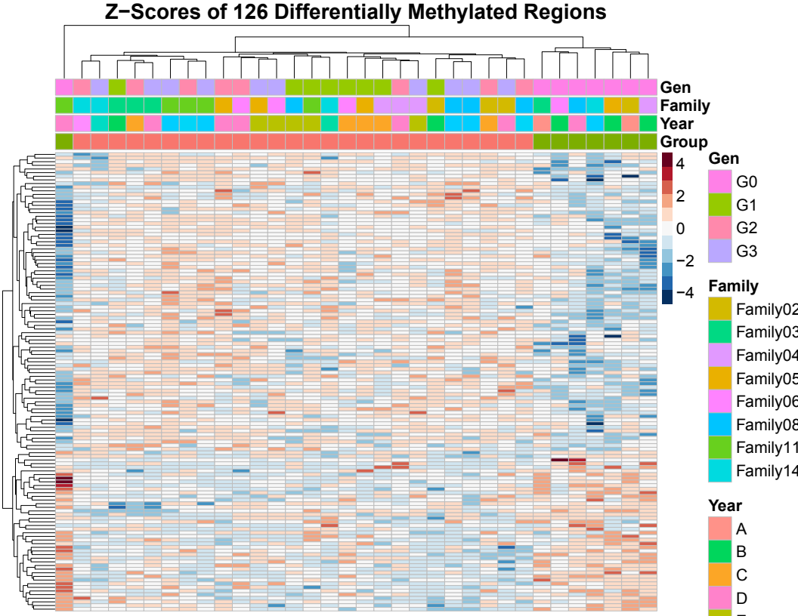

Figure S4. Heatmap of DNA methylation between male hatchery and male wild groups (Group category: green represents wild group and pink represent the hatchery group. Each row is a DMR and each column is an individual. The value in the heatmap is the Z score of methylation percentage. Category information is provided at the top of the heatmap including Group (rearing environment group), Family, and Gen (generation group). Year is included as a covariant the clustering of individuals was still based on the rearing environment.